1 s "c : new" )  getwd()

4  branch_data read. csv(" txt", header TRUE)

6 str (branch_data)

> branch_data read.header TRUE)

> str (branch_data) data. frame• :: 4 variables:

S Branch 3 4 8 g 10 .

S sales_xl 3 . 4 4.1 2. 8 S 3. 7 4. S 2 4. g 3. 2 2. 5 

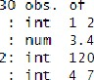

of

obs.

S Advertising_x2: 120 150 go 200 110 175 185 105 80

5 years_X3 3 10 5 6 2 g 4 1

boxpl ot (br anch_dAtASsa1 es_X1 , man n "sox-plot of sales' outl i ne TRUE , outpch=8 , hori zontA1 = TRUE)

# Boxplot of Sales

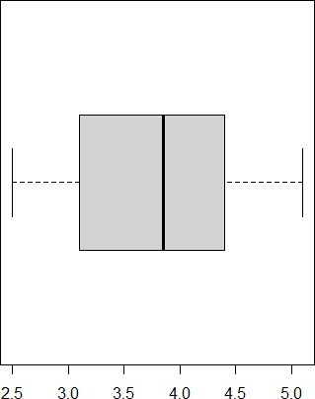

3.5

summary (br anch_dataSAdverti s i ng_X2 fi venum(br anch_dataSAdverti s i ng_X2 IQR (br anch_dataSAdverti s ng_x2)

> ng_x2)

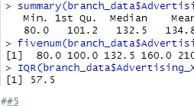

134.8

210.0

ng_x2)

Mean 3rd Qu.

158.8 ng_x2)

get. outliers <- function(z){ q1 <- quantile(z) C 2)

<- quantile(z) iqr <- q3 q1

ub <- q3

1b q1

# print ub)) print 1b)) print ' paste (sort (z [z



Bound

Bound



210.0

 > ubJ) , col 1 apse

get. outl i ers (br

# > get. outliers

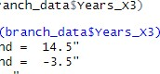"upper sound Cll "L ower sound Cll "outliers: